Step by step instructions for students
- You will first setup the two 11cmX11cm boxes. This telegraph system has a sender and receiver box. The boxes are very similar but have slight differences in the wiring and the sender box has an additional hole for the power.
- Drill 2cm hole in top of box
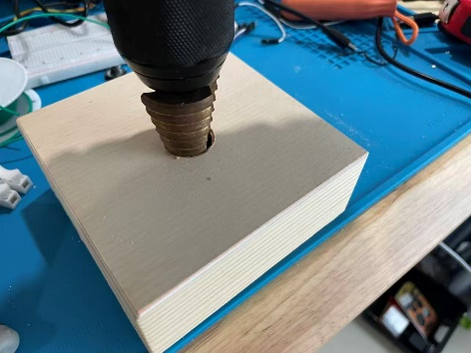
- Drill 14mm hole in front of box. The “receiver” box will have only these two holes. For the “sender” box you need to drill a second 14mm hole in one of your two boxes, one box needs a usb cable).
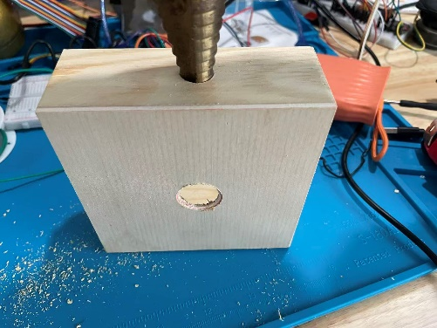

- Unpackage and remove the items from the Telegraph kit. These are the only parts we will use from this kit:
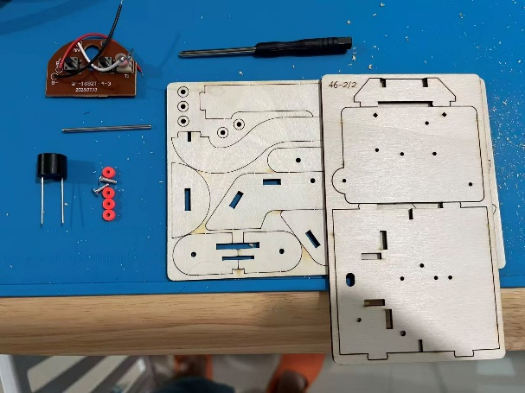
- Ensure the brown button board has the wires added for this project (teacher will have previously done this).
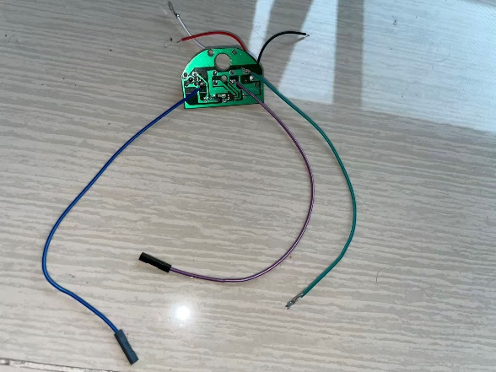
- Assemble the telegraph kit with the parts shown in step three:
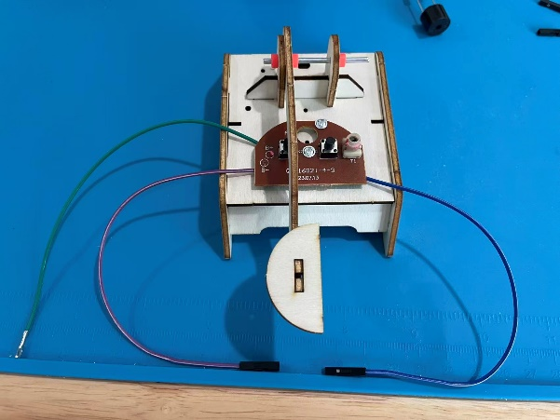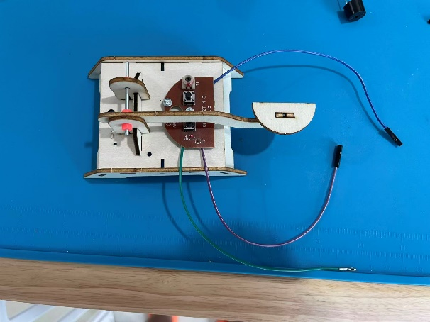

- Take the black buzzer. Attach a long BROWN wire to the plus (+) terminal. Attach a GREEN wire to the other side. Remove the black plastic end from the other end of the green wire
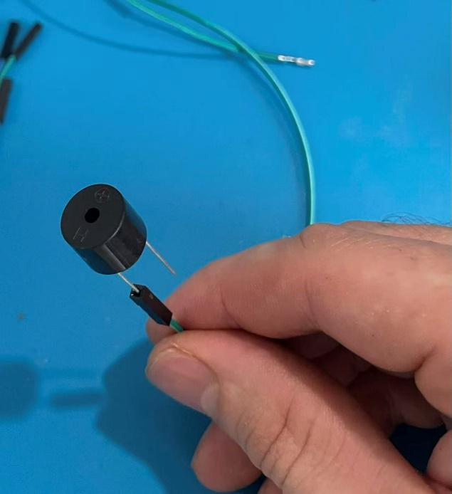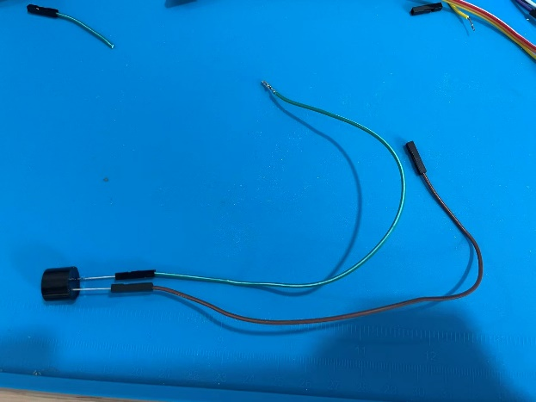
- Apply hot glue to both the green and brown connection (see photo below). Ensure no glue is going between the silver posts. Then mount the buzzer somewhere on the telegraph machine using hot glue.

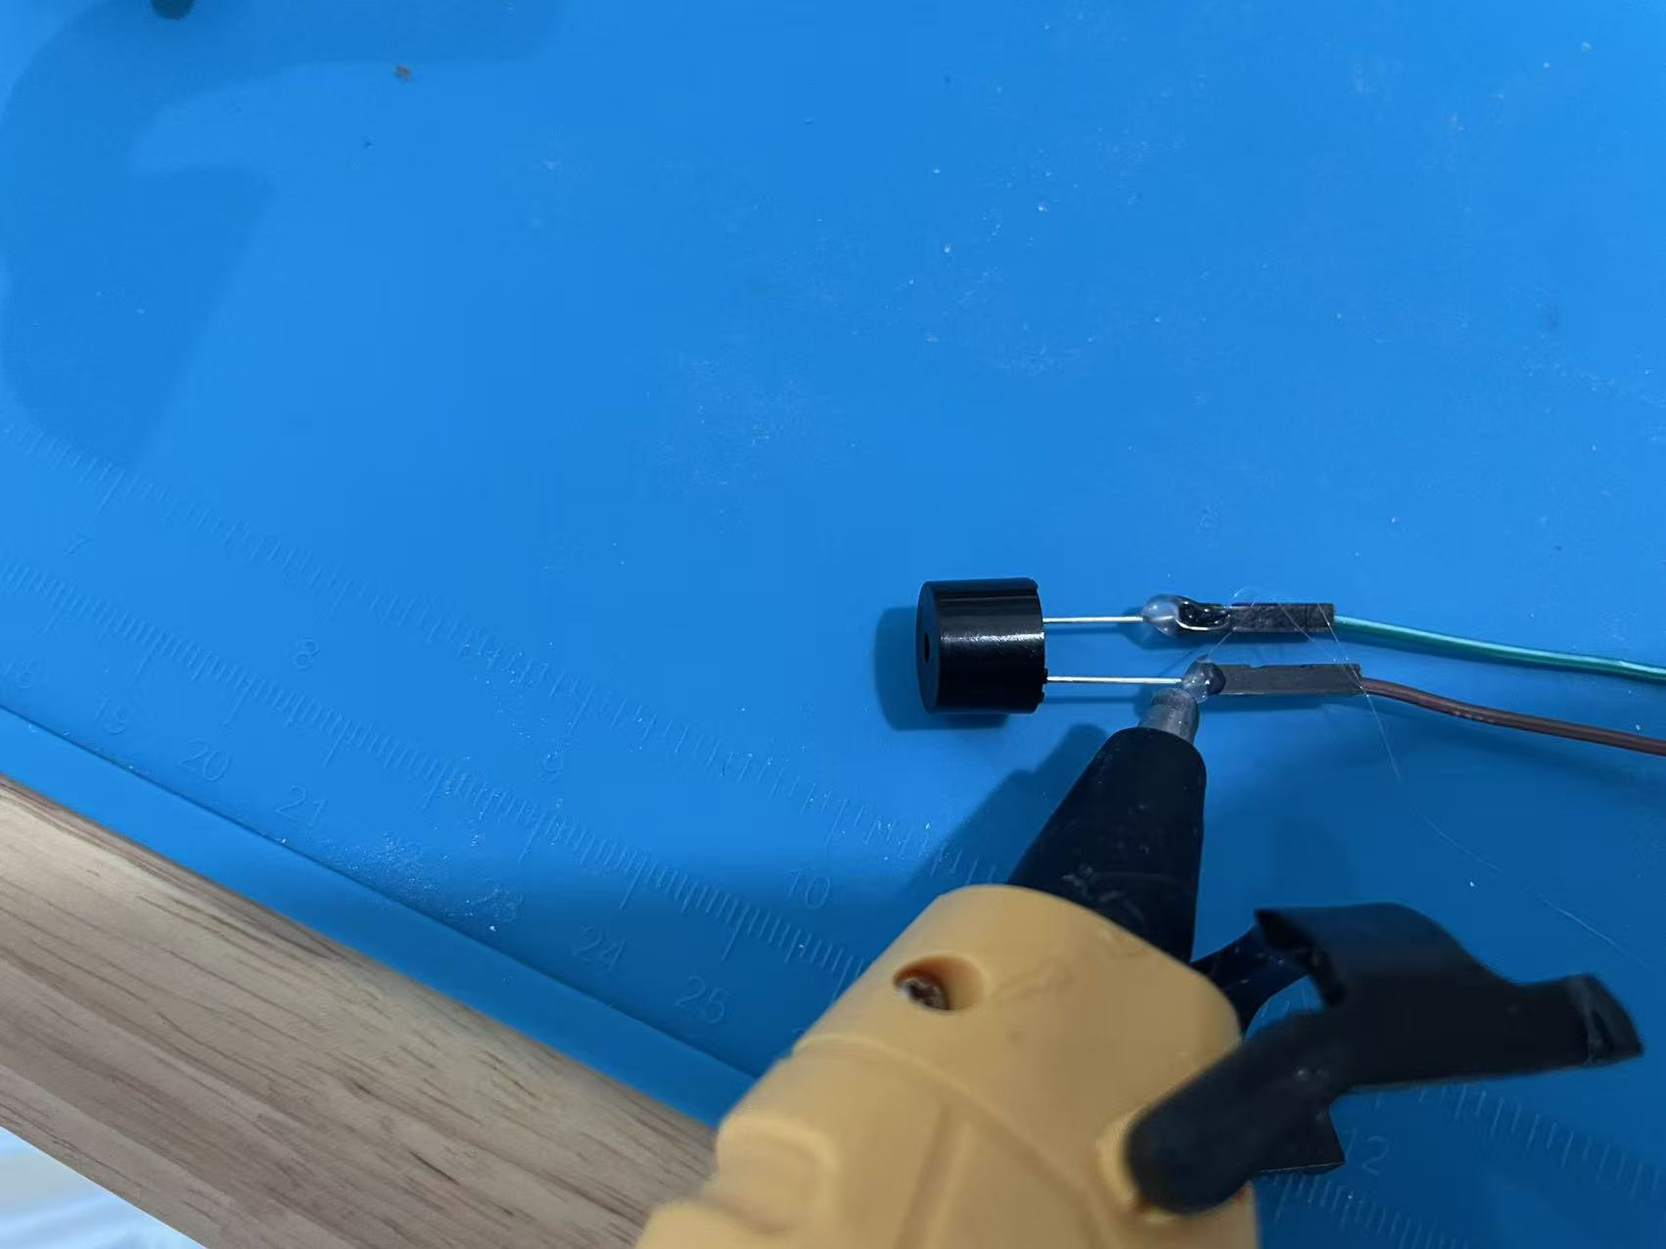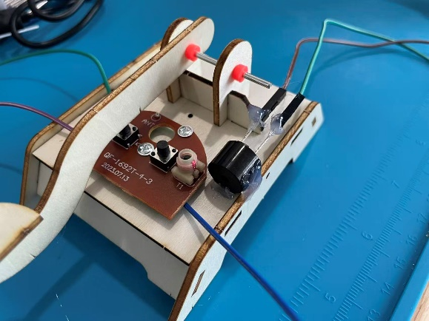
- Use a pen to mark the holes of the screen. Drill one hole with a 1.5mm drill bit to drill the holes. Use 2 of the wooden spaces provided in the kit as a spacer between the screen and the base. Mount the screen with one hole then drill the second hole through the hole of the screen. Use two screws to attach (you need different screws than came in the kit).
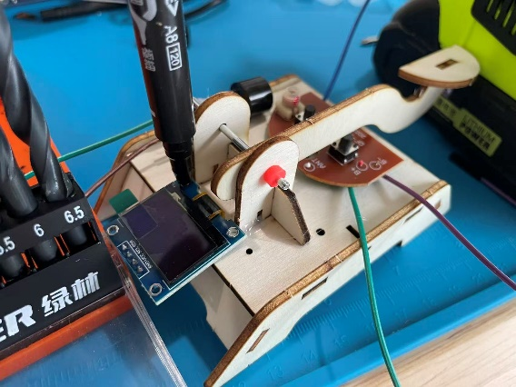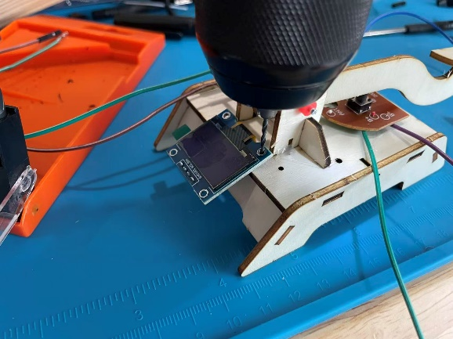
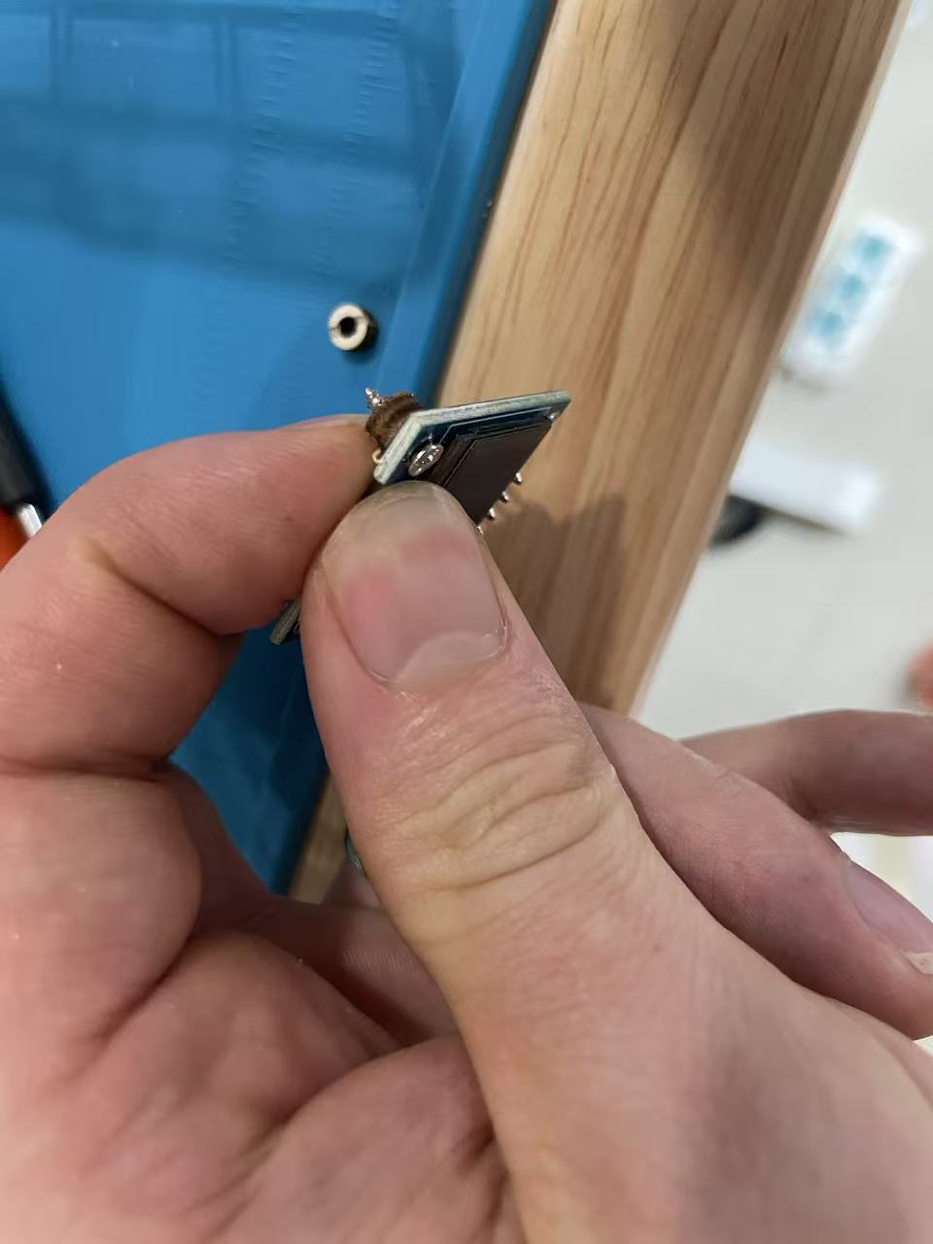
Alternatively, you can use a hole on the kit and mount the screen using the bottom left hole. The screen will be a little sideways, but the install is much easier:
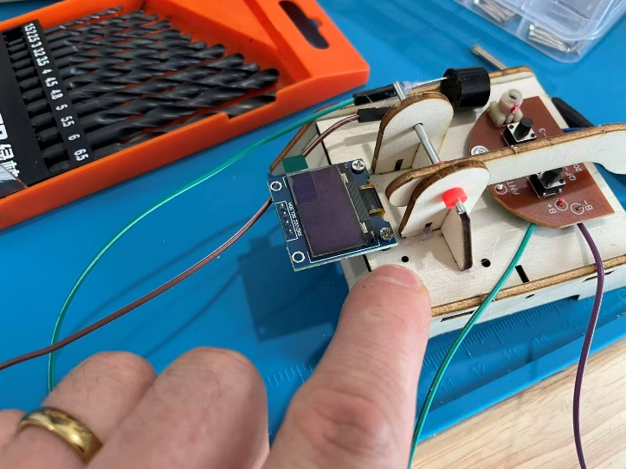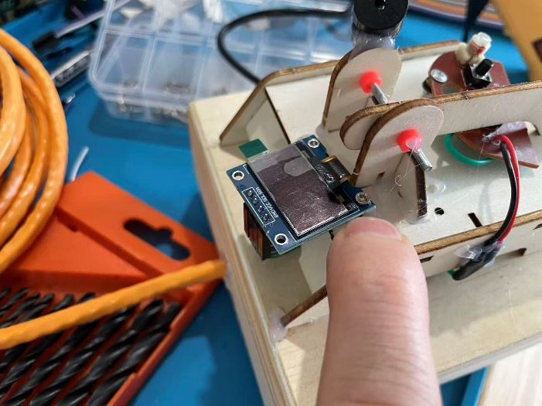
- Take these four wires from your short Female-to-female wire set. Ensure the colors are like this:
GND → Brown (GN )
VCC → Red (5v board power )
SCL → Orange (A5)
SDA → Yellow (A4)
Remove the black plastic end from the Red wire
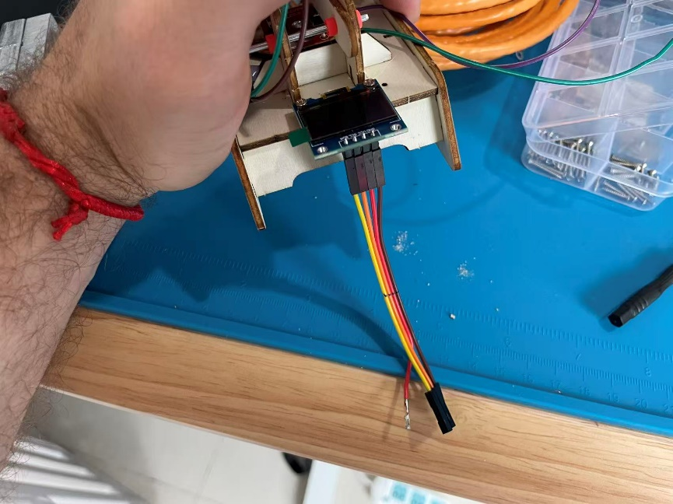

- Now that the Telegraph button half is finished, insert all the wires into the large hole of your box. See the below photos to see how to route each device wires into the hole. ENSURE THE SCREEN IS FACING THE “FRONT” WHERE THE SIDE HOLE IS LOCATED. Add two small hot glue welds to secure the telegraphy machine to the box (when the project is complete we will put more glue here).
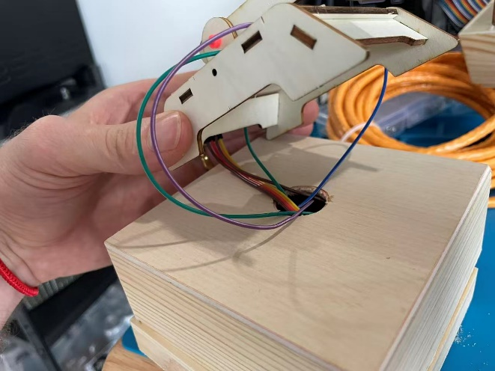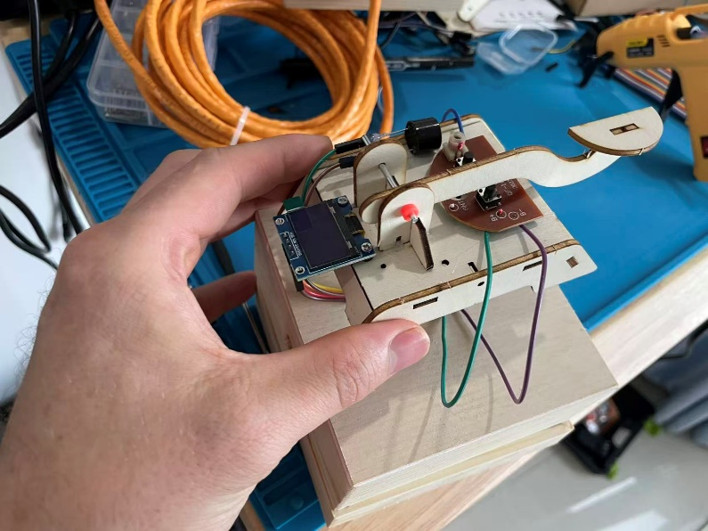
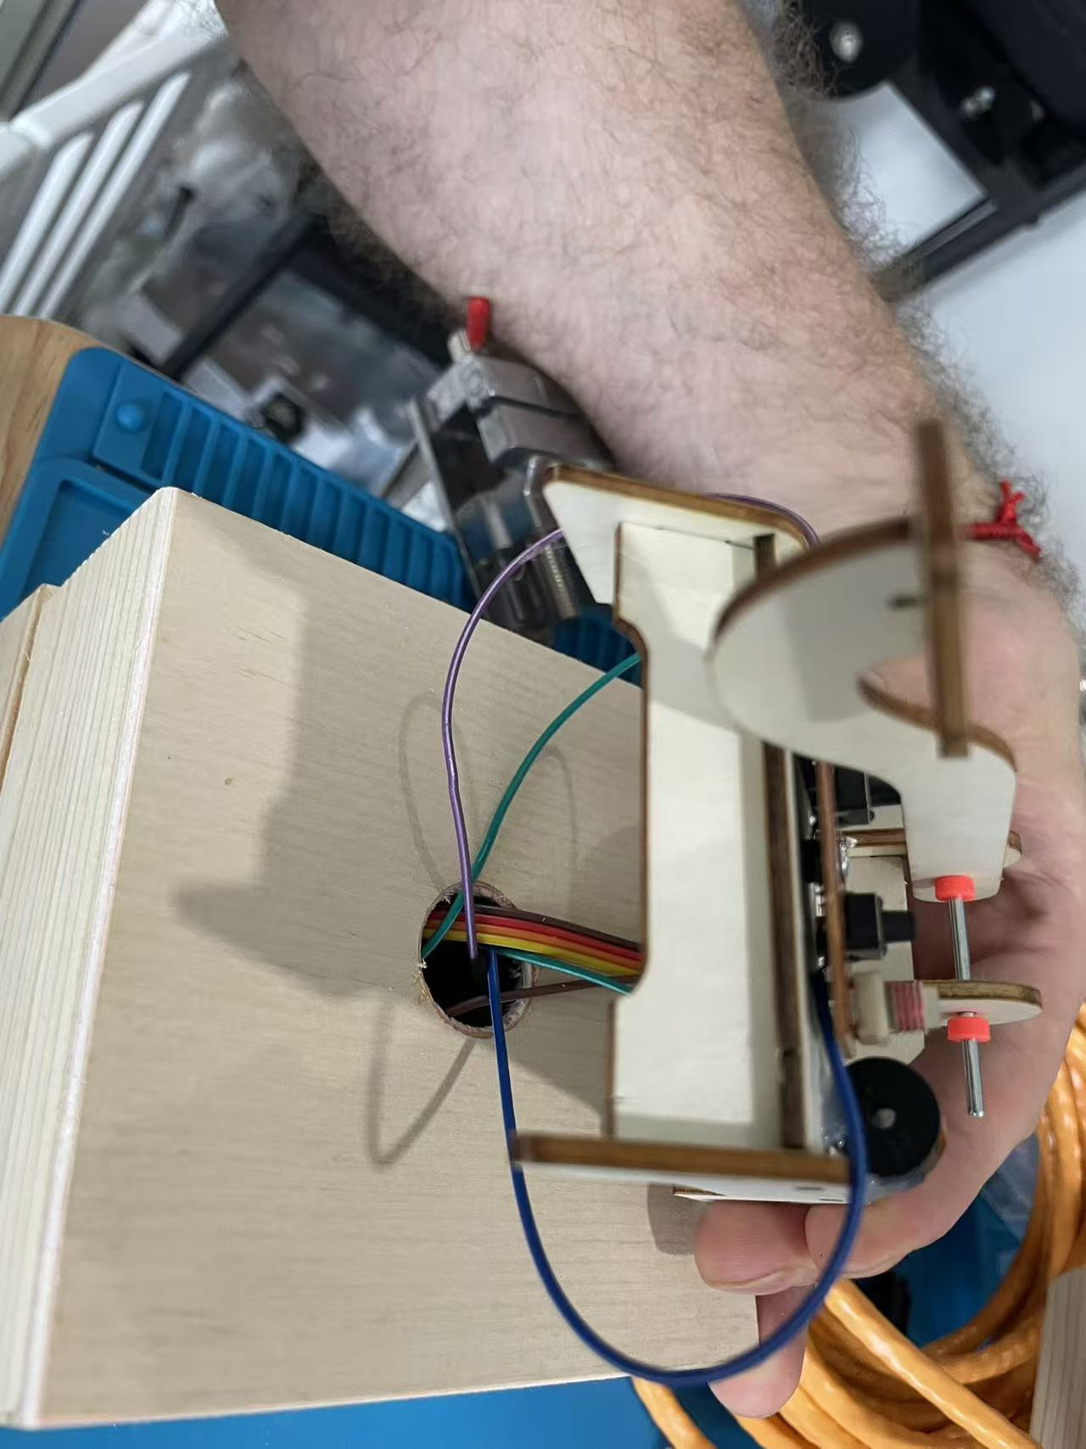
- Prepare (splice) the ethernet cable so its ready to be connected. Optionally, you can install a female-to-female RJ45 (Ethernet) connector to the box to avoid a permeant connection between the two boxes. See photos below.
To prepare the ethernet cable, strip back the plastic coating about 1.5cm from the ends of each of the 8 wires inside.
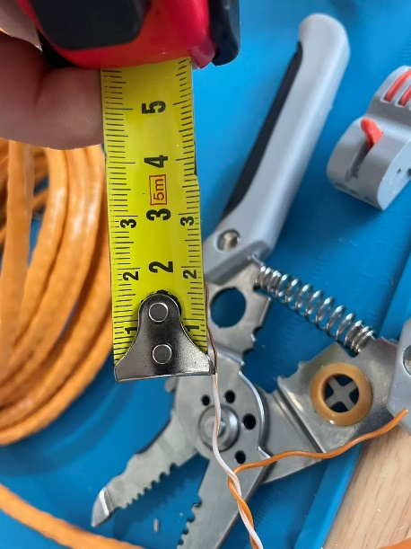
After stripping all the ends, twist together the bare ends of each color. Green to green, orange to orange, brown to brown, and blue to blue:
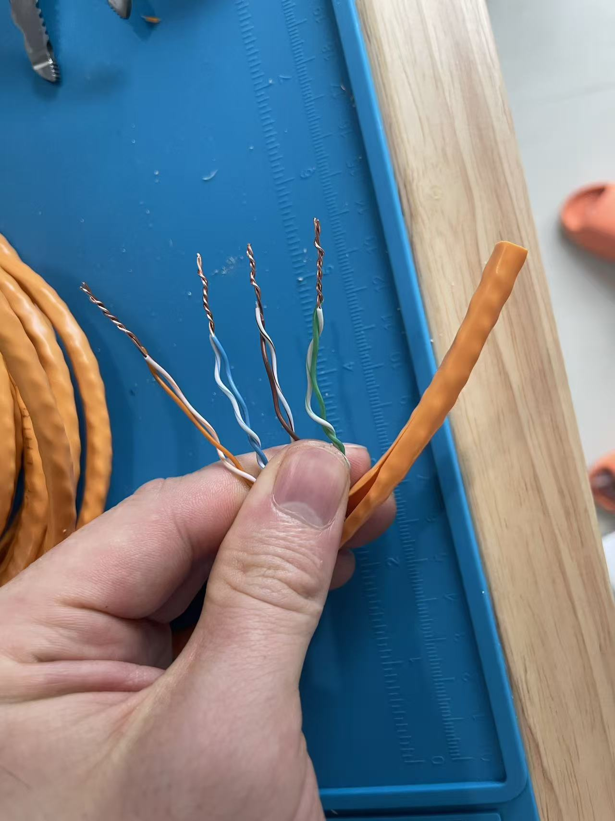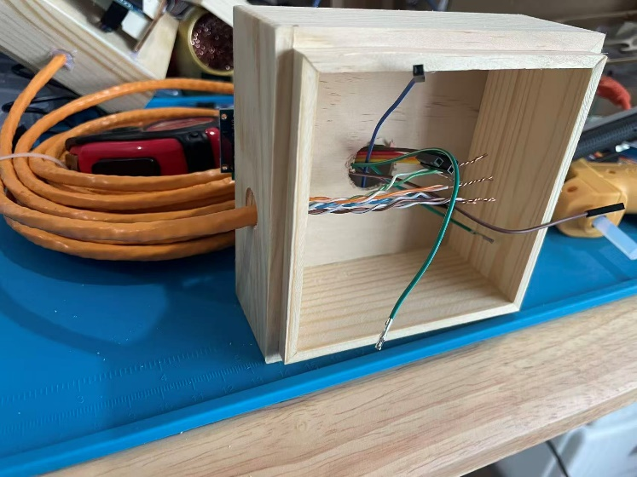

These are the optional RJ45 to Rj45 connectors you can use for a quick disconnect and making the boxes more portable:

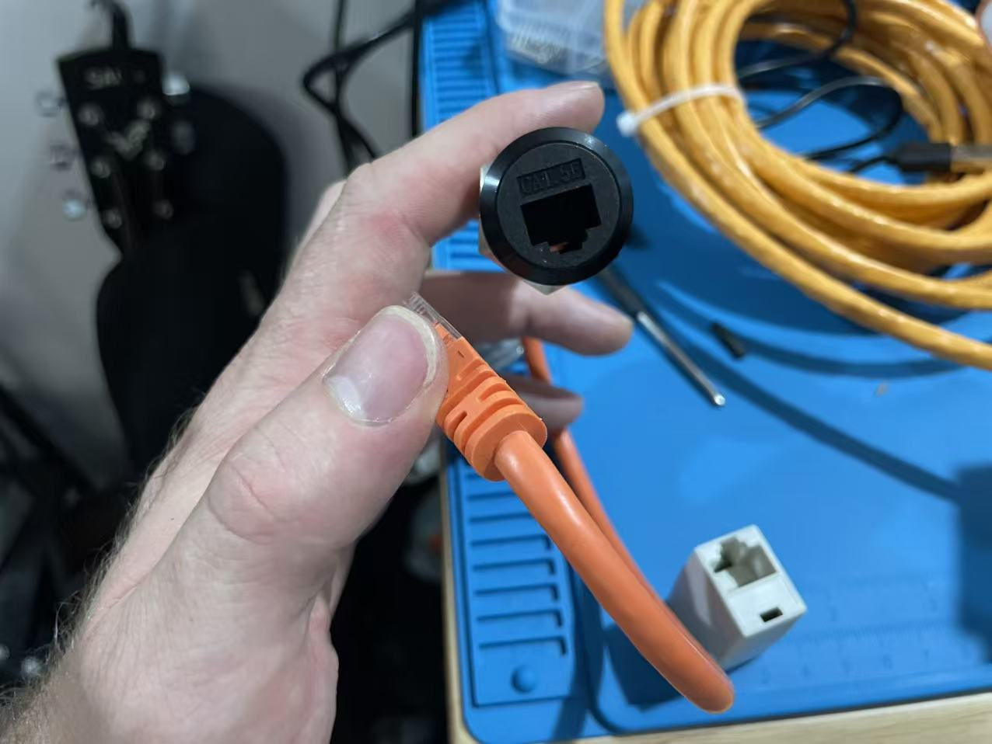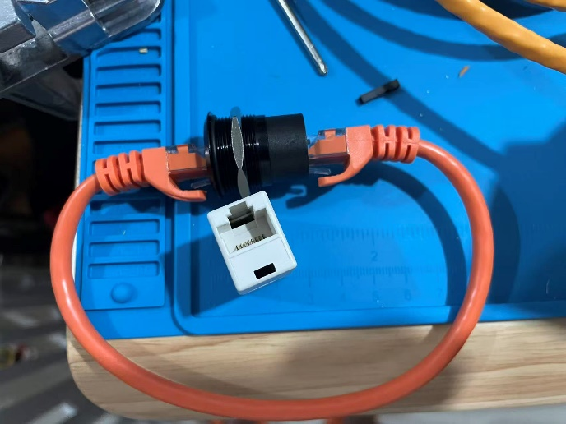

- Take the black plastic off a red, green, blue, and orange wire from your short female-to-female wires:

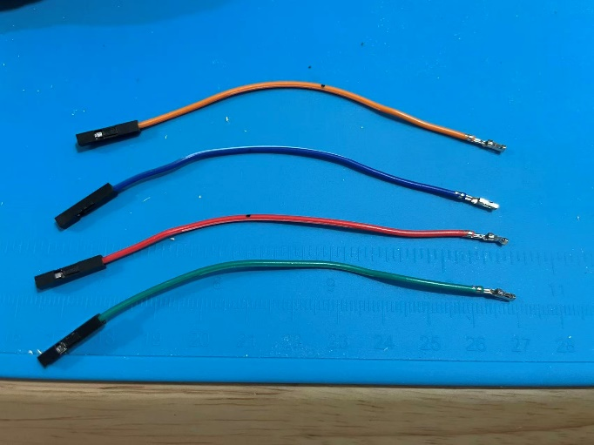
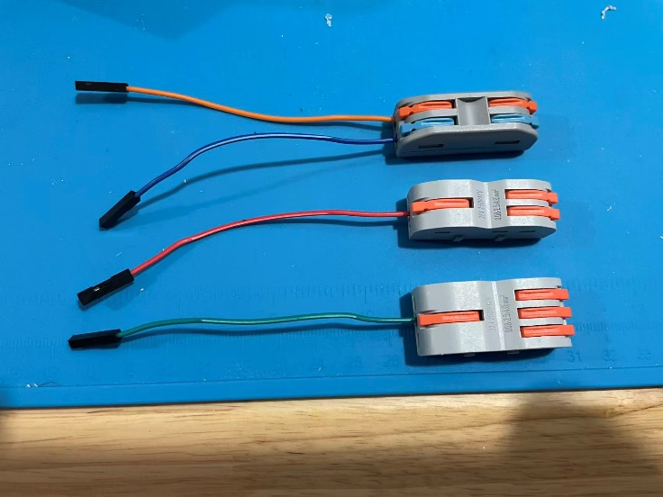

- Follow the wiring schematic to hook everything up. IMPORTANT: The wiring diagram is for the sender box. The receiver box will have D10 and D11 switched. On the receiver box, D10 should have the orange wire an D11 the blue wire. Otherwise, all the grounds go into the 3-to-1 connector with the single side going to the computer. The screen goes to a 2-to-1 connector. The other side of the 2-to-1 connector goes to the opposite box same connector.
Button: one side ground, other side goes to D2
Buzzer: One side ground, another side goes to D6

- When finished and confirmed the system is working, put a small amount of hot glue on each connection to the computer.
